The growing understanding of slow combustion/smoulder ignition and burning raises, we believe, fundamental questions around the UK Furniture (Fire) (Safety) Regulations (FFR). Raising awareness and indeed understanding to bring about the assimilation of the new science will not be easy.

FRETWORK is intent on making some rudimentary testing – based upon the test methods we use every day – to try and demonstrate the new principles in the context of our existing testing regime.
The UK testing regime is actually complex and this is in part due to the way it was developed.

Background.
The original FFR were drawn up in response to a precise and clearly defined problem

The RISK of IGNITION occurring in large articles with PolyUrethane foam filling and an outer textile cover.
This generally meant upholstered furniture.

Analysis of the fires recorded the following characteristics:

Domestic dwellings.
First item ignited: foam filled upholstery.
Smokers “materials” were most often/always involved.
Fire apparent some hours after last human activity at the seat of the fire.
High incidence of death and severe injury, remote from the seat of the fire.
Babies and Children were particularly susceptible.

Scientifically this can be recognised as being due to the large amounts of Smoke and Toxic Fumes (STF) produced under the specific conditions:

Restricted air supply (a closed room),
Delayed ignition (up to 3 hours)
Sufficient material in the first item ignited (foam filled upholstery) providing sufficient smoke and fume to fill the entire house. (including bedrooms/upstairs where occupants were asleep).

How the UK deals with the Risk identified.
There is little to debate surrounding flaming ignition but the details from the standards relating to smoulder ignition are copied here to demonstrate how we work. What and how they describe it is based upon the perception of this aspect from 40 years ago.

FRETWORK’s home web page has a link to a British Rubber Manufacturers Association (BRMA) booklet that is 40 years old but describes this risk scenario.

https://fretwork.org.uk/brma-document-fretwork/

Standards.

The next stage is how the tests are performed and much of this is set out in our Standards. The language and terminology used are fairly consistent but the detail of combinations in a composite and exactly what is being tested are important.

The Regulations.

The FFR is based upon component testing. Different components used in the manufacture of Upholstery (UPH) are set out in the different schedules.

It is as if the Performance requirements part of the standard are replaced by the Regulations.

Different components used in the manufacture of UPH are addressed in the different schedules. The basic description should be clear but further detail and explanation is repeated in the same format in the Annexe.

SCHEDULE 1
PART I
Block or slab PUF used in UK upholstery must meet this testing regime: Crib 5 under a Trevira CS fabric of 220 gsm L shaped rig.

SCHEDULE 1
PART 2
PUF in crumb form used in UK upholstery must meet this testing regime: Crib 5 under a Trevira CS fabric of 220 gsm L shaped rig.

SCHEDULE 1
PART 3
Block or slab Latex foam used in UK upholstery must meet this testing regime: Crib 5 under a Trevira CS fabric of 220 gsm L shaped rig.

SCHEDULE 2
PART 1
Single items used as “secondary fillings” tested on L-shaped rig under standard test Trevira CS fabric using ignition source 2 (next larger gas flame BS 5852).

SCHEDULE 2
PART 2
Fillings other than foam tested as a composite on an L – shaped rig with a Trevira CS cover using IS 2

SCHEDULE 2
PART 3
Filling and cover composites tested on an L – shaped rig with IS 2. Tests for 1. Pillows using THEIR OWN cover and 2. Cushions their own cover AND the standard Trevira CS cover.

SCHEDULE 2
PART 4
Specifically for bed and mattress. Test sample constructed as defined in BS 6807 BUT cover will be standard test Trevira CS fabric. IS 2. The rig is NOT L shaped.

Problems and observations.

The key points are where the “Standard Cover material” is used. The BRMA document shows the issue of the component and the composite being important and that is found throughout the FFR.

There is a fairly constant definition in every BS document for both flaming and smouldering ignition. The reasoning behind the adoption of the Trevira CS fabric as a standard cover is now lost. It is clearly synthetic, certainly thermoplastic and probably has a melting point below normal Polyester.

Anecdotally, it is recognised as being temperature sensitive in textile processing and temperatures used for normal PES will stiffen the fabric and cause discolouration.

The different test methods are critical when it is recognised that potentially char forming and hence smouldering fillings such as cotton batting would be tested under a thermoplastic cover.
It is probably a small and insignificant point that the schedule 3 interliner and Combustion Modified High Resilience (CMHR) foam do not consider smoulder from a cigarette source as necessary – who knows what would happen.
The schedule 4 cigarette test (IS 0) actually does not specify which filling to use and there was a presumption, sadly deluded, that UPH manufacturers would test this aspect. This does not happen other than on a due diligence basis for incoming materials.
What does happen is that Test Houses will perform the IS 0 and 1 on the same rig set up hence a Non CM foam is used.
Even with a fabric cover that passes the IS 1 test there can be fails. (see https://fretwork.org.uk/definitions/uk-ffr-cigarette-test-is-there-a-problem/ ).

We can confirm from discussion between members of FRETWORK that those who process mainly synthetic /thermoplastic fibres have little concern for the cigarette test and those who process mainly cellulosics do have frequent and unexpected test results.

This scenario is further complicated when the bedding sector is considered but that is too complex for this project.

What does happen is that certain tests will assess materials that should give a smoulder risk and yet – probably due to the use of the standard cover – give pass results and are thus marketed as being flame retardant!

The fact that the FFR testing of smoulder ignition may be wrong in our understanding of your work is important. We need to establish evidence to support any action on this subject.

What will FRETWORK do?

We shall perform some test using materials that we can obtain as part of our normal work where we can show (hopefully side by side).

We shall use the FFR test rigs so that our results are put into a context more relevant to the FFR.

In our thoughts are issues such as comparing different fillings with cotton fabrics and standard PES fabric. WE could compare cotton before and after treatment for the schedule 3 requirement. We can easily source that different standard foams such as Non-CM foam (schedule 3 and 5), 20 – 22 k/ m³ CM (schedule 2) and 35 kg/m³ CMHR.

We would welcome your comments and look to investigate any suggestions you may offer and above all share our results with you. I would suggest we should write again when we have assembled our selection of materials.

OUR OBJECTIVES.
Set out a clear definition of 2 types of ignition behaviour for PUF: a) Open flame
b) Smoulder. It may be useful to add a 3rd one for FR PUF (?).
Ensure that test methods are available so that materials can be graded and (importantly) enable comparison with replacement materials.
Ensure that test methods for process control are suitable and effective.
Peter Wragg Feb 2021
ANNEXE.

EXTRACTED FROM TEST METHODS
The language of the test procedures was carefully chosen – this is copied from one standard but the format is fairly consistent in all standards.

EN 1021-1:2014 (E)
2.1
progressive smouldering
exothermic oxidation, not accompanied by flaming, that is self-propagating, i.e. independent of the ignition source. It may or may not be accompanied by incandescence

3 Criteria of ignition
3.1 Progressive smouldering ignition
For the purposes of this European Standard, all the following types of behaviour are considered to be progressive smouldering ignitions:
- a) any test assembly that displays escalating combustion behaviour so that it is unsafe to continue the test and active extinction is necessary;
- b) any test assembly that smoulders until it is largely consumed within the test duration;
- c) any test assembly that smoulders to the extremities of the specimen, viz. upper or lower margins, either side or to its full thickness, within the duration of the test;
- d) any test assembly that smoulders after one hour from the application of the ignition source;
- e) any test assembly that, on final examination (see 9.3), shows evidence of progressive smouldering.
NOTE In practice it has been found that there is usually a clear distinction between materials which may char under the influence of the ignition source but which do not propagate further (non-progressive combustion) and those where smouldering develops in extent and spreads (progressive combustion).

9.3 Final examination
Cases of progressive smouldering ignition undetected from the outside have been reported. Immediately after completion of the test programme on the assembly, dismantle it and examine it internally for progressive smouldering ignition (see 3.1 e)). If this is found, extinguish the test assembly, and record an ignition and complete the test report (see Clause 10). For safety reasons ensure that all smouldering has ceased before the rig is left unattended.
If no internal progressive smouldering ignition is found, record non-ignition and complete the test report (see Clause 10).

BS 5852 : 2006 refers to EN 1021 as above

The Regulations.
The next stage of my explanation is how the tests are performed and much of this is set out in our Regulations. It is as if the Performance requirements part of the standard are replaced by the Regulations.

Different components used in the manufacture of UPH are set out in the different schedules.

SCHEDULE 1
PART I
Ignitability test for polyurethane foam in slab or cushion form 1.

The foam shall be tested in accordance with the method set out in BS 5852: Part 2 using cover fabric corresponding to the specification set out in paragraph 2 below.
2. The fabric shall be made of 100 per cent flame retardant polyester fibre. (The fabric is precisely specified) The fabric finish shall be scoured and heat set. Its mass shall be 220 g per m² plus or minus 5 per cent.
3. The test rig as specified in clause 6.1.1 of BS 5852: Part 2 shall have expanded steel platforms of not less than 28×6 mm mesh size. The test rig is placed on a metal tray of sufficient dimensions to collect any debris falling from specimens being tested. The rig and debris tray shall be mounted on a weighing balance with a remote readout having a full-scale deflection of at least 0 to 20 kg to an accuracy of 2 g.
4. The foam under test, cut to the specified dimensions is placed on the test rig, covered with the fabric specified in paragraph 2 above and tensioned with clips as set out in BS 5852: Part 2. An ignition source 5 crib is placed in position. The mass of the complete assembly is determined (“initial mass”). The test shall be carried out in accordance with BS 5852: Part 2. In particular flaming or smouldering failure shall be determined against the criteria of clause 4 of BS 5852: Part 2.
After flaming and smouldering has ceased, any debris which has become detached from the specimen shall be removed. The remaining mass of the assembly (“final mass”) is then recorded.
5. If failure against the criteria of clause 4 of BS 5852: Part 2 has occurred but only by way of damage exceeding the limits defined in clauses 4.1(e), 4.1(f) and 4.2(f) and provided that the resultant mass loss (initial mass less final mass) is less than 60 g the foam passes the ignitability test.

SCHEDULE 1
PART 2
Ignitability test for polyurethane foam in crumb form.
Description as previous except it details how to deal with crumb rather than slab form.
If smouldering or flaming failure against the criteria of clause 4 of BS 5852: Part 2 has not occurred or has occurred only by way of damage exceeding the limits defined in Clauses 4.1(e), 4.1(f) and 4.2(f), the crumb foam passes the ignitability test.

SCHEDULE 1
PART 3

Ignitability test for latex rubber foam.

As for part 1: filling tested under a specified textile cover.

If smouldering or flaming failure against the criteria of clause 4 of BS 5852: Part 2 does not occur, the latex rubber foam passes the ignitability test.

SCHEDULE 2
PART 1
Ignitability test for non-foam filling materials singly. (single items used as “secondary fillings” tested).

SCHEDULE 2
PART 2
Ignitability test for composite fillings for furniture other than mattresses, bed-bases, cushions and pillows.
The composite fillings, covered with the primary cover are built up on the test rig as described in BS 5852: Part 2. The covering fabric shall be that specified in paragraph 2 in Part I of Schedule 1. The test procedure with the use of ignition source 2 specified in BS 5852: Part 2 and the criteria of failure shall be as specified therein.

SCHEDULE 2
PART 3
Composite test for ignitability of pillows and cushions with primary covers.
1. For pillows the test specimen shall comprise the filling and the primary cover of the pillow. Where the filling is of a loose nature the specimen shall be prepared as set out for loose fillings in paragraph 3 in Part II of Schedule 1. The test procedure using ignition source 2 shall be as specified in BS 5852: Part 2. If smouldering or flaming failure against the criteria of clause 4 of BS 5852: Part 2 has not occurred or has occurred only by way of damage exceeding the limits defined in clause 4(1)(e), 4(1)(f) and 4(2)(f), the composite pillow filling passes the ignitability test.
2. For cushions with primary covers the test specimen shall be made up of filling, the primary cover and standard fabric as in Schedule 1 Part I, paragraph 2. Where the filling is loose, it shall be packed as set out in Schedule 1 Part II, paragraph 3. The test procedure using ignition source 2 shall be as specified in BS 5852: Part 2. If smouldering or flaming failure against the criteria of clause 4 of BS 5852: Part 2 has not occurred or has occurred only by way of damage exceeding the limits defined in clause 4(1)(e), 4(1)(f) and 4(2)(f) the composite cushion filling passes the ignitability test.

SCHEDULE 2
PART 4
Ignitability test for composite fillings of mattresses and bed-bases.
1. The test specimen shall be prepared as set out in BS 6807. It may be constructed from the filling materials to be used or by removing existing ticking from a mattress or upholstered divan or bed-base.
2. The specified test fabric as in Schedule 1 Part I paragraph 2, shall be used as the cover fabric. It shall be fitted so as to reproduce the tension in the original article where this is being tested.
3. The test shall be carried out according to Section Four of BS 6807 using ignition source 2 as specified in BS 5852: Part 2. Smouldering or flaming failure shall be as defined in BS 5852: Part 2

SCHEDULE 3.

Test for INTERLINER COVER fabric made over 20 – 22 kg m³ NON combustion modified foam.
Ignition source is 5 or crib 5.

The pass criteria is according to clause 4 of BS 5852 part 2 which is similar to the definition given earlier and thus including a progressive smoulder examination.

SCHEDULES 4, 5 and 6 are for cover fabrics suing the flame and smoulder ignition sources 1 and 0.

ANNEXE 2

In textiles we find the following table of great use in enabling us to predict burning behaviour of textiles that can (yes!) contain up to 7 different fibres.
We have sought to extend this to include the foam materials but would welcome any additions you can offer.
The testing of the PUF as a component to be used is critical to the Risk Assessment and this can be explained in 2 very informative pictures:

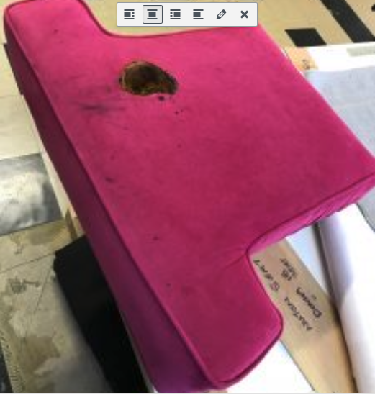

The first picture (taken on a smart phone) on the effect of a charging malfunction of a modern smart phone on an item of UK manufacture PUF filled upholstery.

The second picture is from a mattress and was recorded by Staffordshire Fire Service (see: https://www.staffordshirefire.gov.uk/news/latest-news/near-escape-involving-tablet-charging-overnight/ ). Their report is, we believe, entirely in line with our FFR Principle 2.
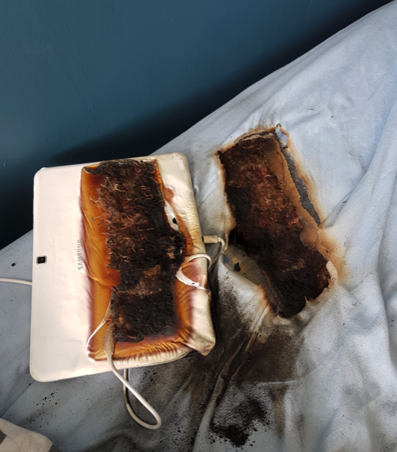

In case it is not immediately apparent we should emphasise that the lack of ignition:

Does validate the stringent test performance required by the FFR for PUF.
Does equate to ‘limited’ SMOKE AND TOXIC FUMES (STF).
It does NOT equate with the POTENTIAL amount of STF if the foam had ignited/been completely consumed.
The objective of ignition resistance for PUF is crucial.
The event will not contribute to Death and Causality fire statistics.

Ignition resistance is important when the Risk Scenario is considered and not the same thing as a reduced rate of burning.
The problem then follows as to how we take the component testing and performance approach adopted by the FFR and turn that to Final Product performance requirements without losing the specific Risks identified in the FFR.

Thermal properties of commonly used Textile fibres
Including comparative data for TDI PUF
Fibre | Regain  % Moisture | LOI  % oxygen | Melting Point ºC | Ignition Temp. ºC | Self-ignition  Temp. ºC | Thermoplastic behaviour
Acrylic | 1.5 | 18 | 215 - 255 | 250 | 515 | chars
Cotton  Cellulose | 8.5 | 19 | Not relevant | 350 | 400 | chars
Polyamide  Nylon | 4.0 | 20 | 215 | 420 | 450 | melts
Polyester | 0.4 | 22 | 250 | 390 | 508 | melts
Polypropylene | 0 | 19 | 145 | 350 - 370 | 390 - 410 | melts
Viscose  Regenerated Cellulose |  |  |  |  |  | chars
Wool | 20 | 25 | Not relevant | 325 | 590 | chars
TDI PUF  = NON CMHR FOAM | 0 | 16 | NOT AVAILABLE | Thermal degradation 260 | na | chars
CMHR FOAM | 0 | NA | NA | Ca 300? | na | chars

