THE CASE FOR RE-EVALUATING OUR APPROACH TO TESTING FOR SMOULDER IGNITION LEADING TO COMBUSTION

FRETWORK has re-published on its web site the BRMA booklet on flexible polyurethane foam (PUF) from the 1980’s and this shows clearly the understanding of that time for 2 different types of ignition associated with articles containing PUF.
The FFR, drawn up during that same period, adopted a very precise approach to testing and smouldering ignition. This has been repeated in time through various published standards to maintain a consistent approach to the subject of smouldering ignition.

However, various Articles, Reports and Surveys published during recent years have demonstrated a developing understanding of the phenomena known under many names but including Slow Combustion or Smouldering Combustion.

This is typified by several key features:

- Ignition is by (relatively) low energy sources.

- Oxygen supply is very restricted and must remain so to maintain the combustion conditions.

- The process emits smoke and toxic fumes (STF) characterised by the restricted oxygen supply at far higher levels than the same materials under normal flaming ignition.

- The process represents a high degree of incomplete combustion whilst open flame ignition requires higher levels of oxygen and shows more complete combustion.

- The smouldering combustion process may develop to the point where a transition to flaming behaviour can occur Smoulder to Flame or StF). This can be related to flash-over conditions and adds a further dimension to the Risks presented by PUF and textile composites.

It is clear that combinations of PUF and textile cover, as found in upholstery, can demonstrate smouldering ignition in a way that is different to open flame ignition.

Our demonstrations of the two types of ignition are shown in APPENDIX 2.

Combinations of PUF and textile must be tested for both types of ignition.

The relevance of this new approach is reinforced by the continuing concerns that STF as a cause of injury and death remains at disturbingly high levels in spite of the influence of the FFR on casualty figures.

The question “does the present testing regime for the FFR adequately address these risks” must be answered.

- Smouldering ignition source (IS 0) remains the only reliable ignition source (interrupted smoulder cigarettes excepted). It requires an improvement.

- Tests made as a composite with a thermoplastic cover are unlikely to develop smoulder conditions as the melting of the cover textile allows oxygen (air) supply to allow normal ignition to occur and cannot develop or demonstrate smoulder ignition.

3. Thermoplastic cover fabrics may avoid smoulder ignition risks although this statement must be qualified by actual testing of cover and filling combinations.

2. is represented in the experience of FRETWORK Group. Those who process a majority of synthetic fibre fabrics have little or no problem with I S 0 testing whereas it is more often an issue for companies processing mainly cellulosic fabrics. It should be noted that in all cases we are considering failures on cover textiles that have met the I.S. 1 testing requirements.

It is important that testing is carried out using the L – shaped rig and similar devices used in UK testing regime to ascertain whether or not these findings can be replicated using the UK testing regime.

Anecdotally, there is evidence that this is likely to prove affirmative as those carrying IS 0 testing may be aware that neglected test rigs demonstrate the smoulder to flame transition (StF) that is described as part of the phenomenon.

A further point is to remember that the UK testing regime is strictly directed towards identifying ignition and the methods of assessment of smoulder ignition are limited in a very precise way so that we remain in the area of ignition prevention and not burning behaviour.

As the tests refer to the use of a thermoplastic cover being used it may be that further evaluation of the method may demonstrate that nothing should fail this test.

All of this would be of little consequence were it not for the fact that most materials tested here are synthetic fibre based but we must presume that most natural fibre materials seem to be listed as materials that will potentially demonstrate smoulder in the literature.

OPSS are looking to encourage new/novel approaches to achieving fire safe upholstery and having test procedures that recognise and test for the risks will be important. Are we to presume that only synthetic filling materials will be used? How will alternate systems of fillings perform in comparison?

It is of considerable importance that we have a testing regime that will not only properly assess present materials but will allow the evaluation of new materials in the most meaningful way.

ANNEXE 1.

There is nothing new in smoulder as can be seen in the BRMA booklet from the early 1980’s reproduced on the FRETWORK web site:
https://fretwork.org.uk/brma-document-fretwork/

Selected quotes from the BRMA booklet:
“…When considering ignition sources it is important to distinguish between smouldering ignition from such sources as cigarettes and other smoking
materials and ignition of small open flames such as matches and cigarette
lighters.”
And
“The fire-statistics available in Europe do not, at present, allow a distinction to be made between cigarette and match ignition. It is the opinion of BRMA, however, that the substantial percentage of UK casualties in the early morning, 00.00 to 05.00 hours is a strong indication of smouldering ignition.
And
“Care is necessary when generalising on the effect of these flame retardant additives on smoke and gas evolution. In recent years two types of foam have
been developed which give improved flame retardance when small flame sources are used, These foams are usually referred to as ‘High Resilience’
foams and Neomorphic foams.”

More recent works demonstrate a growing understanding of the phenomenon:

“During flaming combustion of polyurethane foams, the yield of toxicants can be directly related to the fuel/ air ratio, expressed as an equivalence ratio (φ). This results in relatively high yields of CO and HCN during under-ventilated flaming and relatively low yields during well-ventilated flaming. “

McKenna and Hull Fire Science Reviews (2016) 5:3 DOI 10.1186/s40038-016-0012-3. The fire toxicity of polyurethane foams. Sean Thomas McKenna and Terence Richard Hull.

“Under ventilated” would seem to describe very well the smouldering cigarette scenario of the BRMA booklet.

Gas Emissions
Gas emissions from smoldering fires differ significantly to those from flaming fires. First, the emissions rate per unit area is much lower but also the chemistry is different. Smoldering is characteristically an incomplete combustion, releasing species and quantities that substantially depart from that in stoichiometric and complete combustion. For example, the CO/CO2 ratio which can be thought of as an index of the incompleteness of combustion is ~0.4 in smoldering but ~0.1 in flaming combustion [46]. The presence of pyrolysate in the products of smouldering, significantly contributes to of a complex gaseous mixture including volatile organic compounds (VOC), polyaromatic hydrocarbons (PAH), other hydrocarbons and particulate matter (PM). While the yield of toxic species is larger in smoldering fires than in flaming fires [47], the production rate, which is proportional to the spread rate, is much lower. This means that inside an enclosure, a smoldering fire of long duration (in the range from 1 or 3 h for a single bedroom size compartment [48]) can lead to a lethal dose of toxicity, especially CO. But there are not as yet sufficient data on the toxicity of smoldering materials to definitively understand the issue of life safety. Some more information is presented in Chap. 62 and in [47].

Guillermo Rein (private communication) (probably) published as part of, SFPE Handbook of Fire Protection Engineering, 581 DOI 10.1007/978-1-4939-2565-0_19, # Society of Fire Protection Engineers 2016

In an item on Slow combustion Speight notes the following materials that can exhibit smoulder ignition and some “typical” examples where it may be found:

“….. Solid materials that can sustain a smouldering reaction include coal, cellulose, wood, cotton, tobacco, peat, coal duff (coal fines), humus, synthetic foams, charring polymers including polyurethane. Common examples of smouldering phenomena are the initiation of residential fires on upholstered furniture by weak heat sources (e.g., a cigarette, a short-circuited wire), and the persistent combustion of biomass behind the flaming front of wildfires.”

James G. Speight PhD, DSc, PhD, in Handbook of Industrial Hydrocarbon Processes (Second Edition), 2020

This would suggest that any new or novel materials used in upholstery and exhibiting thermal insulation properties (i.e. physically similar to PUF) may demonstrate smoulder.

The article that has based its research more specifically on foam filled upholstery is

Morgan AB, Knapp G, Stoliarov SI, Levchik SV. Studying smoldering to flaming transition in polyurethane furniture subassemblies: Effects of fabrics, flame retardants, and material type. Fire and Materials. 2021;45: 56–67. https://doi.org/10.1002/fam.2847

The research is based upon testing materials in composite form and includes some items that are near to those we would see in the UK and manufactured according to the FFR.

“The overall results collected on these combinations of materials show that material combination matters in the transition from smoldering to flaming. How a material will hold onto heat and propagate a smoldering front into more flammable materials (polyurethane foam) will determine the probability of flaming ignition, and likewise, if a material can melt back from a heat source, it is more likely to create an air gap that prevents the smoldering material from reaching the more flammable polyurethane foam. In modern furniture today, there are seat backs that have no polyurethane foam present at all, and how those materials would perform against such a heat source suggests that they will just melt away from the heat source. However, polyester is a flammable material, and this should be verified rather than assumed to see if looser polyester fiber-fill padding, rather than the thicker polyester batting used in this article, would indeed result in expected melt back behavior, or fire events.”

Private communication Alex Morgan 23/02/2021: “I think there is lots of data that shows synthetic thermoplastic fibers which melt will melt away from a cigarette source and not lead to flame propagation from a smolder ignition source. We’ve certainly seen this in our work, and I believe there are other publications out there on the subject.”

This statement is totally reflected in the experience of testing during manufacture to the requirements of the FFR by FRETWORK Group members.

ANNEXE 2.

FRETWORK has organised some trials to try to demonstrate the behaviour of different materials in the context of the UK L – shaped Rig as described in BS 5852: 1979. Fire tests for Furniture. Methods of Test for the ignitability by smoker’s materials of upholstered composites for seating (and others).

The tests are conducted within a full knowledge of the requirements of the test methods and the FFR but are made purely as demonstrations of combining different types of materials. These tests would not normally be made. The tests are used to determine the performance of particular items (cover fabric or filling). However, the use of the standard Polyester fabric used as a cover in certain tests and specified for manufacture and use in testing by the FFR is helpful as it puts the tests and the way they are specified into context.

The tests are shown as still photographs through the test procedures and details of the different materials is given. Our conclusions are appended after the photos.

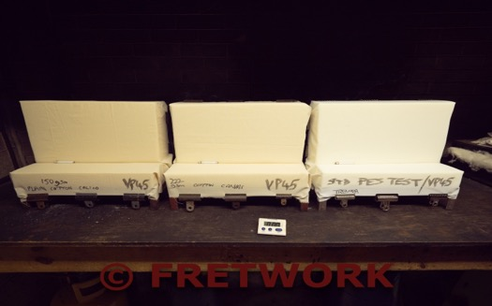
Photo 1.

The cigarettes have been placed at the start of the test.
3 test rigs furnished with non (Combustion modified (CM) foam known generically as “VP45” although it uses the name of a commercial product. There is no actual traceability from the supply chain for this type of product.
The covers are from Left to Right

1 150 gsm non-FR 100% cotton fabrics in a plain weave.
2 220 gsm non-FR 100% cotton fabrics in a plain weave.
3 The standard polyester test fabric specified by the FFR.
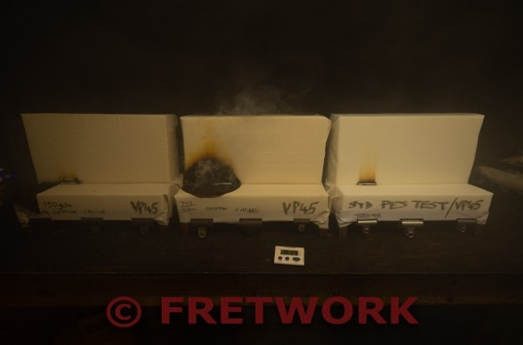
Photo 2

End of test (some 18 minutes later).
N.B. The excessive amount of STF, coming in particular from the middle sample but both 100% cotton covered rigs showed clear evidence of “Progressive Smoulder” as defined by BS 5852. The LHS sample (150 gsm cotton) has burnt equally badly but in a not untypical pattern.

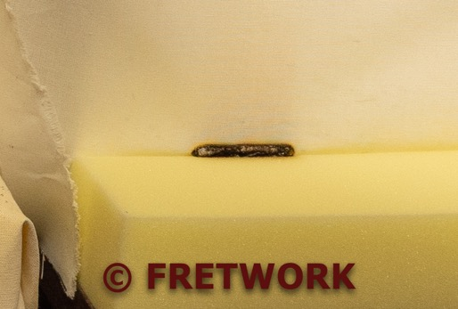
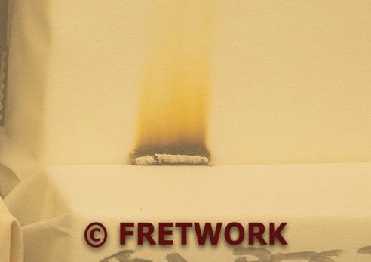
Photo 3 and 4

This shows the effect on the sample covered with FFR polyester (IFRM), both as in the test and (rhs) with the cover fabric stripped back.
It is possible to see a gap of some 3mm in front of and behind the cover to indicate that melting caused by the heat from the cigarette has opened sufficient space to allow air ingress and stop progressive smoulder starting. A Pass result without doubt.

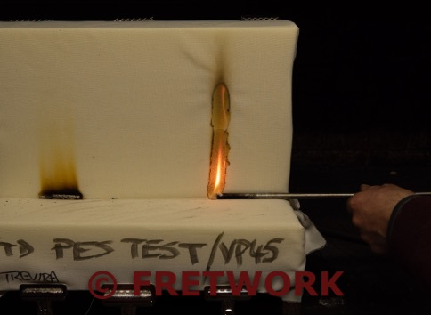
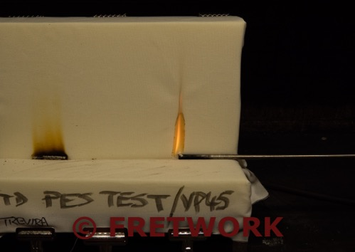
Photo 5

This shows an ignition source 1 applied as per BS 5852 very shortly after application and the again 8 seconds later. Melt withdrawal of the textile (IFRM) allows ignition of the non-CM foam.
And at the end of the 20 seconds flame application time: FAIL
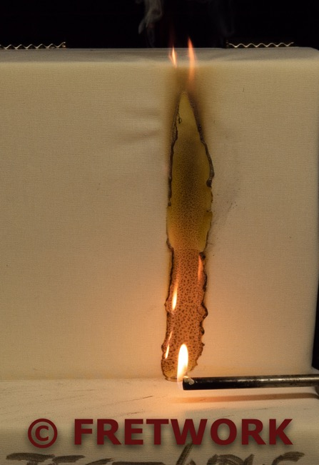

Photo 6

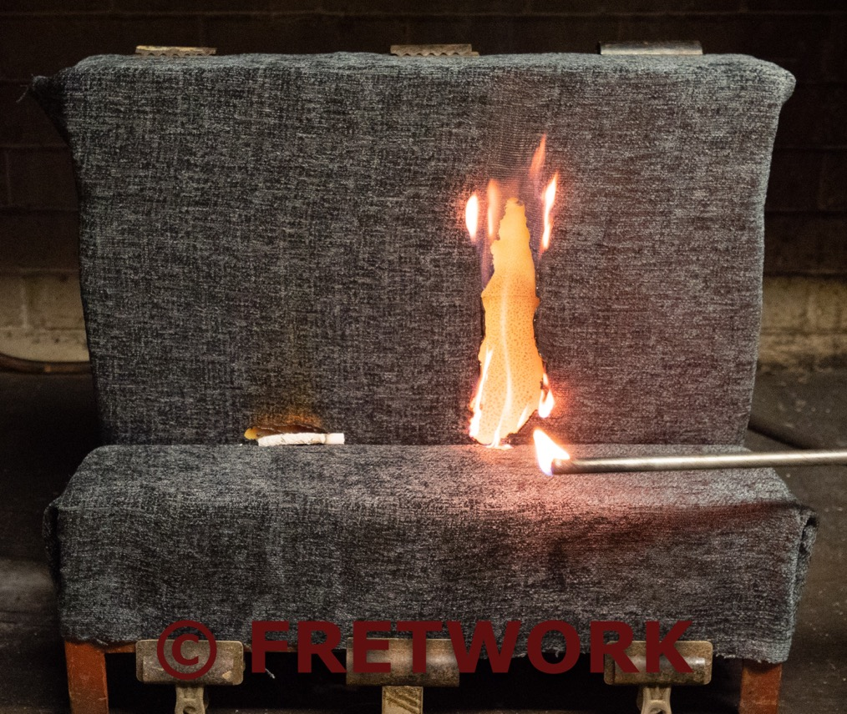

This photo shows the same tests applied to the FFR specified IFRM cover but replicated with a standard commercial polyester fabric – no flame retardant.

The Smoulder test has passed but the IS 1, whilst being slightly slower to burn, has failed – as would be expected. The photo is taken at the instant as the flame is removed from the test sample after 20 seconds application.

FRETWORK conclusions.

The demonstrations show clearly that when thermoplastic textile cover fabrics are used over Non-CM foam then the IS 0 (cigarette) will not develop smoulder ignition. The match test in this case demonstrates the Risk of Ease of Ignition with an open flame.

This is in agreement with the Paper presented by Dr. Alex Morgan et al referenced in annexe 1.

Our demonstration has relevance in the UK being based upon use of the L-Shaped Rig.

This work
was made possible through the cooperation of several subscribers to FRETWORK in supplying test materials, test facilities and, most precious of all, their time.

FRETWORK will continue with this work by examining filling materials and their ignition behaviour with smoulder sources using thermoplastic and charring cover textiles. The indications gained here may hold considerable significance as the present review of the FFR is likely to require evaluation of new and novel materials as a prioritised requirement.

We would like to thank Dr Alex Morgan and his colleagues for their help and support in this demonstration.

FRETWORK
10th April 2021

